DIPTI M SAHOO
AZ-900 Certified A z u r e D a t a Engineer

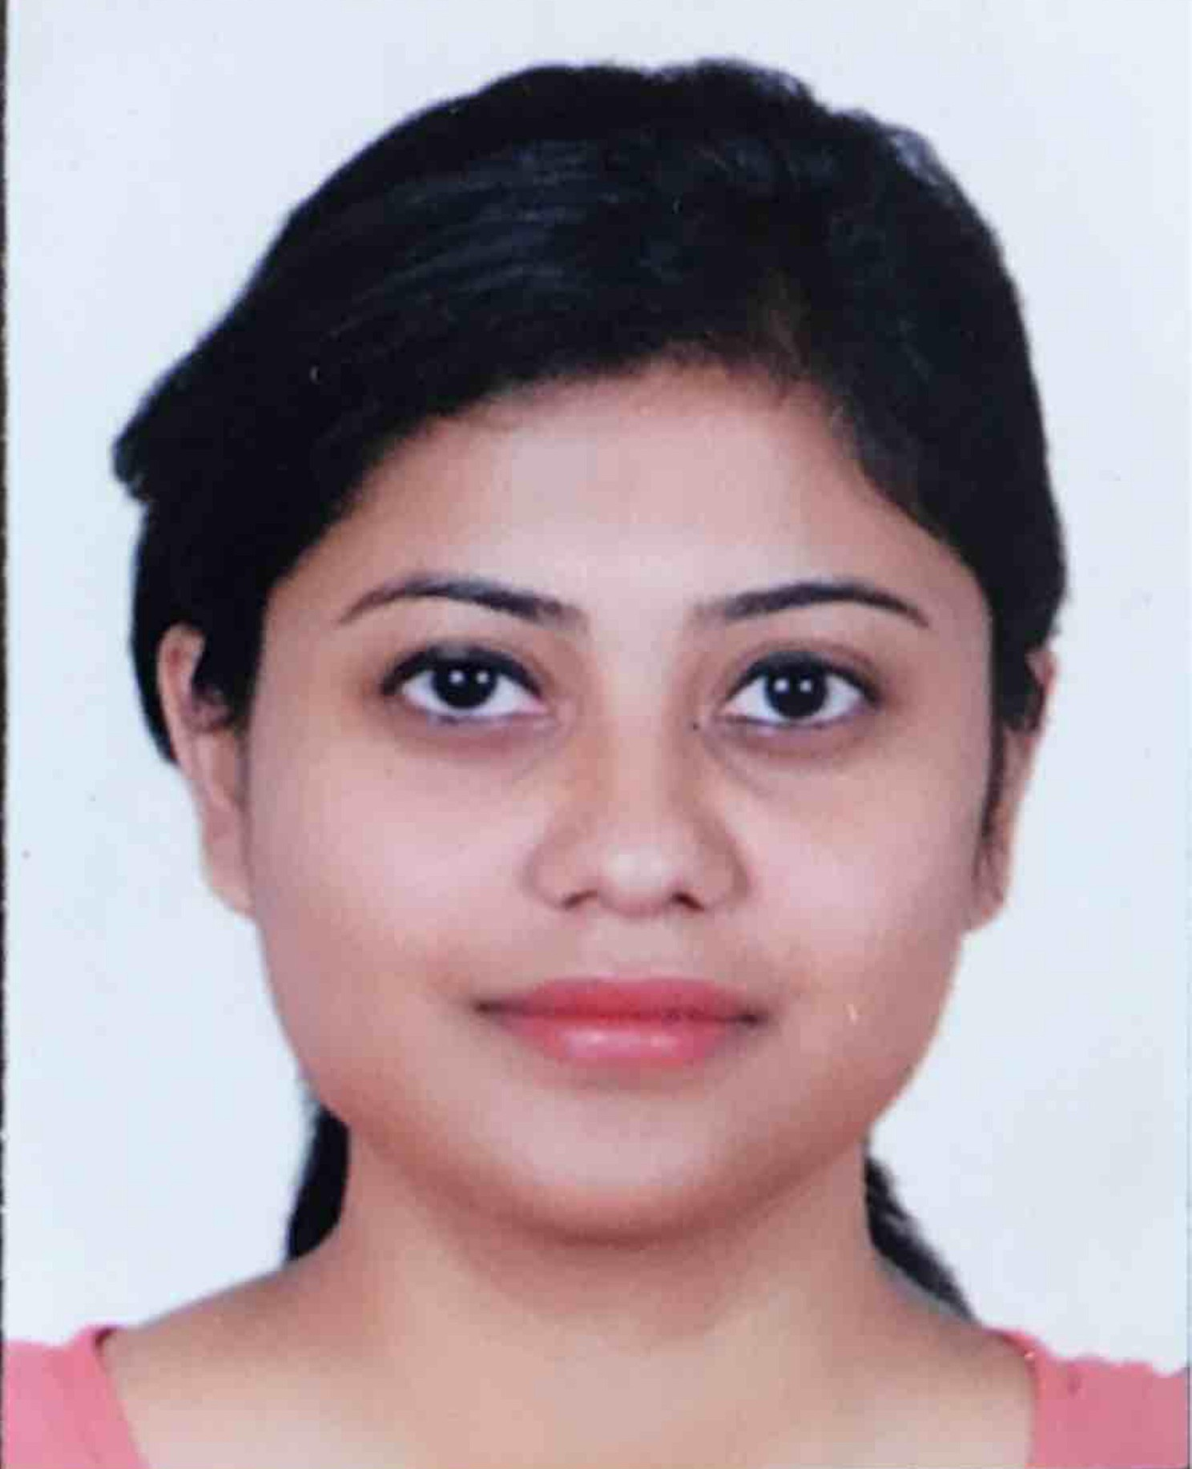


+65 8453 1064
 dipti.puppu@gmail.com #17-136,BLK 155, Rivervale Crescent,Senkang,540155

EDUCATION
Bachelor of Technology
GIET , Odisha , India
2005 - 2009

EXPERTISE
Data Factory
Mapping and Modelling Workflow Automation Pipeline ERD
Data Warehouse
Report Generation

SKILLS
Azure Data Factory Synapse
ETL
Power BI
SQL, TeraData
Unix Shell Scripting Jenkins , GIT

LANGUAGE
English
Hindi Odiya

Experience
April 2023- Present Deloitte@U3Infotech Azure Data Engineer
Designing and creating Data architectures that align with business requirements.
Selecting appropriate data storage with Azure such Azure SQL Data Ware house, Azure Data Lake Storage or Azure Cosmos DB.
Assisted in data collection and analysis, performing data cleansing and transformation tasks using Power Query to prepare data for reporting.
Developed DAX calculations and measures to support data analysis efforts. Developing data ingestion to bring data into Azure diverse source, including databases, files, streaming data and external APIs.
Building ETL process to clean, transform and enrich data.
Performing data transformation using tools like Azure Data Factory, Azure Databricks or Azure Synapse Analytics.
2018-2018
OCBC Bank@Comtel Solutions

Data Engineer
Implemented best practice for data modelling, including adherence to data modelling standard, naming convention and documentation, ensuring consistency and maintainability across projects.
Conducted data modelling versioning, impact analysis and change management ensuring smooth transition and minimizing disruption to ongoing projects.
Validated data model against business rules, performed data modelling reviews and provided recommendations for data modelling optimization, resulting in improved data quality and performance.
2016-2018
Standard Chartered Bank@Inforay

MDM Developer
Created golden source of data using Teradata Master Data Management.
Prepare Detailed Design document, Functional Scope Document Installation document and maintain process related documents.
Creating data models, workflow and performing integration test and E2E test in Development Environment.
2013-2016
Goldman Sachs/American Express@Infosys

Technolgy Analysts
Prepare Detailed Design document, Sequence Diagrams, Class Diagrams, Installation document and maintain process related documents.
Working as a Java Programmer in a banking domain application named Maintain Demographic Update
Created Java Tool (single and batch) for this service for testing team to test this application.
Providing Support during SIT and bug fixing when needed
Building and Deploying code into E1 and E2 server using Jenkins and Lara Deployment.
Implement the design and perform Unit testing.
Performing integration test and E2E test in integration environment.
2010-2013
Deutsche Bank@HCL Technology

Software Engineer
Providing L2 support to the client for TLM environment
Loading, clear down, proofing of items in the TLM from backend.
Developing UNIX shell scripting for automation of various activities like file loading, Taking the database health checkups in terms of space issue, performance issues and interacting with DBA team accordingly.

